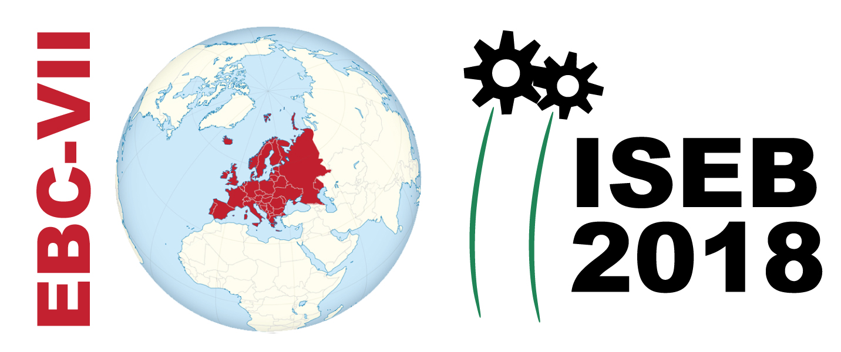
REGISTRATION AND ABSTRACT SUBMISSION FORM
Title:

Corresponding Author or Conference Participant (with no presentation)
Name:
Affiliation:
Address:
Email:

Presenting Author* (if different from above)
Name:
Affiliation:
Address:
Email:
* Each participant can present up to two papers (oral or poster)
CONFERENCE PARTICIPATION (only)
Indicate your preference:
ORAL POSTER EITHER
Indicate the topic(s) that fit best your abstract (e.g., 1, 4, SS3):
- In-situ (bio)remediation of contaminated soil and groundwater, reactive barriers
- Ex-situ bioremediation of contaminated soils, sludges and solid waste
- (Bio)remediation of sites contaminated with crude oil, petrochemicals and PAHs
- (Bio)remediation of sites contaminated with chlorinated and other recalcitrant compounds
- Phytoremediation technologies for decontamination of organic pollutants – Constructed Wetlands for emerging compounds, pharmaceuticals & priority pollutants
- Biotransformation and removal of emerging compounds, pharmaceuticals and priority pollutants.
- Phytoremediation and bioremediation technologies for removal of heavy metals
- Biomonitoring and bioremediation of contaminated sediments.
- Marine Pollution: Technologies to combat marine oil spills, plastics and microplastics / Monitoring and Early Warning Systems / Biomarkers and biosensors
- Molecular biology applications to bioremediation
- Bioreactor technologies for ex-situ treatment, biological wastewater treatment
- Microalgae for wastewater treatment, biofuels and bio-products
- Innovative approaches and tools for monitoring and bioremediation of emerging pollutants in soils, sediments and groundwater
- Waste biorefineries: Integrated (bio)chemical valorization (via biomolecules, fine-chemicals, biomaterials and bioenergy production) of agro-industrial byproducts, effluents, wastes and surplus
- Mathematical modelling of remediation processes and performance evaluation / ecological modelling
- Wastewater treatment, valorization, bioremediation, disinfection and reuse

Special Sessions
SS-1. Water for Africa (H2020 WATER projects overviews)
SS-2. Water for Africa (Technical Papers)
SS-3. Plastics biodegradation & marine litter (plastics & microplastics) P4SB, BIOCLEAN
SS-4. Blue Growth in Med Sea (organized by EFB/Environmental Biotechnology Section)
SS-5. Remediation of metal-contaminated aquifers (REGROUND)
SS-6. Circular economy and waste valorization (INVALOR, IAMAW)
SS-7. Assessing Long Term Environmental Impacts: The role of observatory science

Complete this form and email it together with your abstract to: secretariat@ebc-vii.tuc.gr

